**GANPAT UNIVERSITY**

**U. V. PATEL COLLEGE OF ENGINEERING**

**B.Tech CE/IT Semester IV**

**2CEIT404: Python Programming**

**Practical-4: Lists and Tuples**

1. Explain difference between insert, append and extend operations on list. Write a program to create and initialize list with your name, enrollment number, age, branch and result. Perform insert, remove, update, append and extend operation on list.

**Code:**

l1 = ["Vandan Patel",20012011130,19,"CE",]

print("List")

print(l1)

l1.insert(1,'Hello')

print("Insert Value")

print(l1)

l1.remove("CE")

print("remove")

print(l1)

l1.append("code")

print("append")

print(l1)

l1.extend("india")

print("Extend")

print(l1)

l1[3]="Computer Eng."

print("Update value")

print(l1)

**Output:**

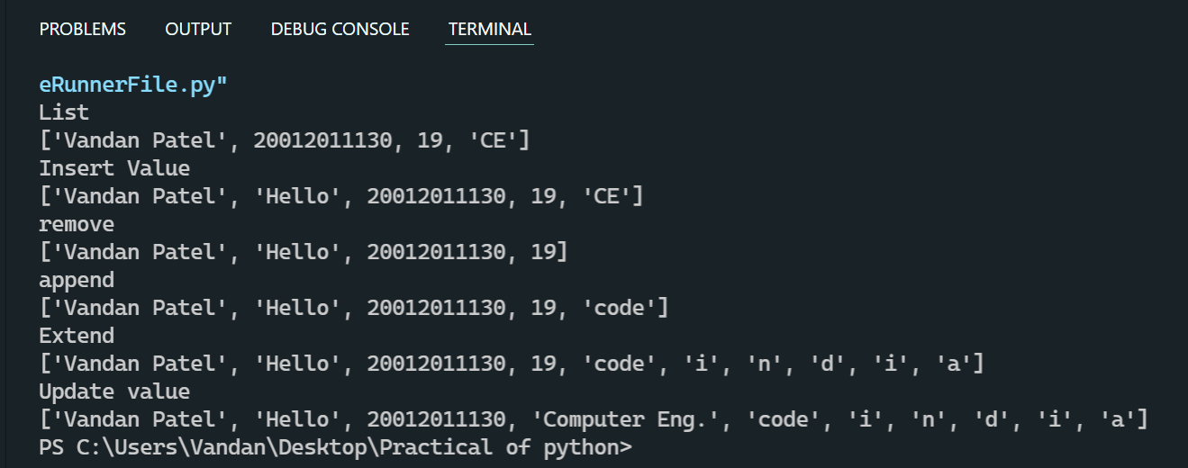

1. Write a program to search an element, find maximum & minimum value from the list.

1. Using inbuilt function

2. Using for loop

**Code:**

l1 = [12,34,5,65,2,4,99,41]

maximun_value = max(l1)

print("Maximum:",maximun_value)

minimum_value = min(l1)

print("Minimum:",minimum_value)

**Output:**

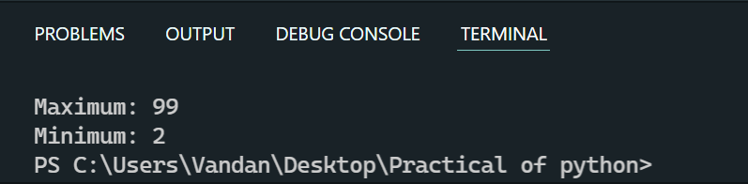

1. Create a program that asks the user for a number and then prints out a list of all the divisors of that number.

**Code:**

n = int(input("Enter number:"))

l1 = []

*for* i *in* range(1,n):

*if*(n % i == 0):

        l1.append(i)

        print(f"Divisor of number {n} is {l1}")

**Output:**

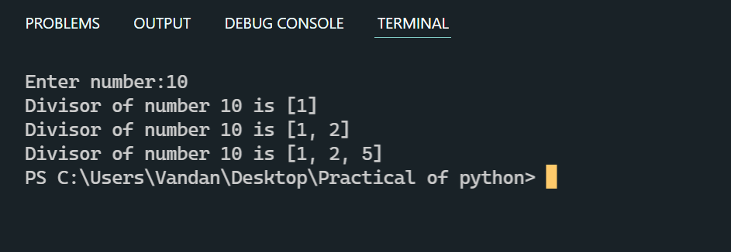

1. WAP to sort element in list

1. In same list

2. Create sorted copy of original list & print both.

3. Sort without any built-in function

**Code:**

l2 = [45,12,78,32,54,99]

l3 = l2

l3.sort()

print("List of l3:",l3)

my_list= [12,321,98,-78,67,94]

new_list = []

*while* my_list:

    min = my_list[0]

*for* x *in* my_list:

*if* x < min:

            min = x

    new_list.append(min)

    my_list.remove(min)

print(new_list)

**Output:**

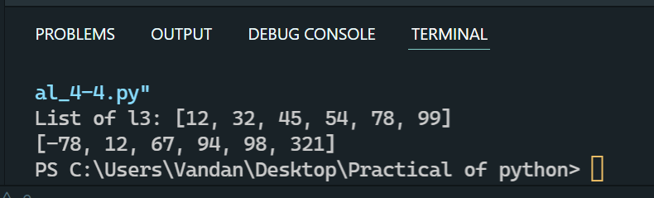

1. Take two lists, say for example these two:

a = [1, 1, 2, 3, 5, 8, 13, 21, 34, 55, 89]

b = [1, 2, 3, 4, 5, 6, 7, 8, 9, 10, 11, 12, 13]

and write a program that returns a list that contains only the elements that are common between the lists (without duplicates). Make sure your program works on two lists of different sizes.

**Code:**

l1 = [10,54,21,34,61,87,94]

l2 = [65,24,21,87,32,54,67,18,97]

l3 = []

*for* i *in* l2:

*if*(i in l1 and i not in l3):

        l3.append(i)

print(l3)

**Output:**

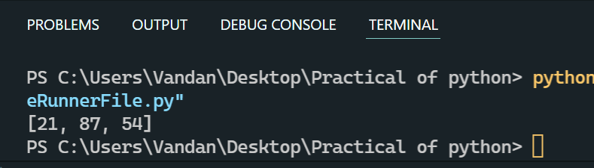

1. Write a Python program which takes a list and returns a list with the elements "Shifted left by one position" so [1, 2, 3] yields [2, 3, 1].

Example: [11, 12, 13] → [12, 13, 11]

**Code:**

l1 = [41,21,54,64,87]

l2 = []

*for* i,j *in* enumerate(l1):

    l2.insert(i-1,j)

print(l2)

**Output:**

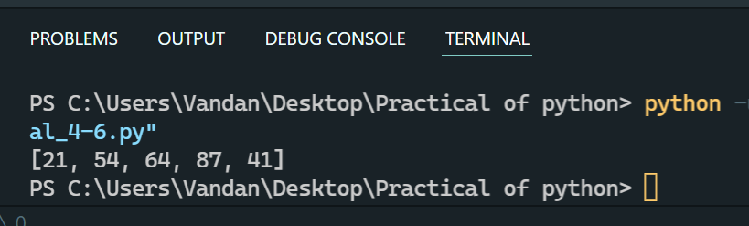

1. Write a program which takes a comma separated string from user & store each string which separated by comma in list & display list.

**Code:**

print("20012011130_Patel Vandan")

st= "Hello,Good morning"

sep=st.split(",")

print(sep)

**Output:**

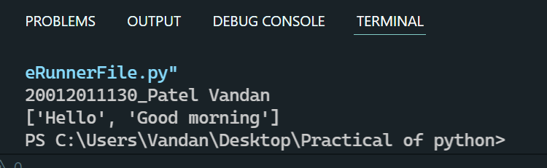

1. Write a program to create and initialize the tuple. Also remove 3rd element from tuple.

Code:

print("20012011130_Patel Vandan")

t1=[1,2,3,4,5,8]

t1=t1[0:2]+t1[3:]

print(t1)

Output:

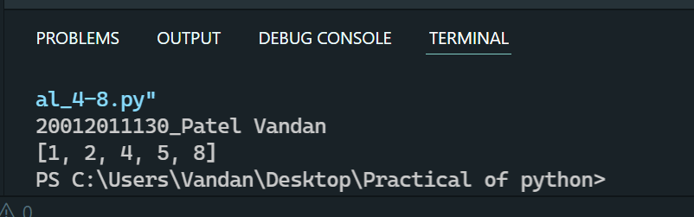

1. Create a tuple with name courses and initialize it with JAVA, PHP, C#, Android. Insert two items HTML and Python at the 3rd position in tuple.

**Code:**

print("20012011130_Patel Vandan")

t1=["JAVA","PHP","C#","Android"]

t1=t1[0:3]+['HTML','Python']+t1[3:]

print(t1)

**Output:**

